|  |  |
| --- | --- |
| Stella Nova Logo | LOGO4 |
| Best Buy Canada Mobile | |
| |  | | --- | | **Tender Feature Document** |   **Document Version: 1.2**  **Design Date: November 01, 2013** | |
| **Prepared By: Amy Lackas** | |
|  | |

**Table of Contents**

*1.**Feature Overview* 3

1.1 Feature Description 3

1.2 Assumptions 3

1.3 Parameters and System Settings 3

1.4 Interfaces 3

*2.**USE CASE: Tender* 4

2.1 Feature Flow 4

2.2 Precondition 4

2.3 Main Flow 4

2.4 Alternate Flows 5

2.5 Post Condition 5

2.6 Special Requirements 5

*3.**Supplemental Specifications* 7

3.1 Credit/Debit/EMV Feature 7

3.2 Electronic Journal 7

3.3 Gift Card Feature 7

3.4 House Account Feature 7

3.5 Layaway/Pre-Order Feature 7

3.6 Manager Override 7

3.7 POSLog 7

3.8 Printed Receipts 7

3.9 Tender Void Feature 7

*4.**Screen Layouts* 8

4.1 Tender Options 8

*5.**Business Sign Off* 10

*6.**Revision History* 10

7. Appendix A: Source Documentation 10

7.1 Functional Requirements 10

*8.**Appendix* B*: Glossary* 10

# *Feature Overview*

## Feature Description

The Tender feature describes the screen flow that is executed when the operator selects to tender a transaction. The system supports multiple tenders to apply to the transaction and provides access to tender void and various additional tender options.

## Assumptions

1. All text displayed by the system is configurable by brand to support multi-language. Text is defined from an external source or defined within the system.
2. The system assigns the transaction number to the transaction at the start of the transaction and does not happen at the time of tendering.
3. The system supports multiple instances of each tender type.
4. If there are multiple instances of the same tender type, the system displays each instance separately.
5. The system masks account numbers when the tender type is added to the virtual receipt.
6. If no payment device associated with the device, the system does not recognize that a card is inserted or swiped on the payment device.
7. A payment device needs to be associated with the device in order for the debit and EMV processing to be initiated.

## Parameters and System Settings

|  |  |  |
| --- | --- | --- |
| **Parameter Mnemonic** | **Description** | **Valid Values** |
| Available Tenders by Device | Determines which tenders are available for a device | * Credit/Debit * Gift Card * Store Credit * Loyalty Certificate * House Account * Layaway/Pre-Order |
| Tender Void Manager Override | Determines if manager override is required to continue with the Tender Void option. | * On * Off |

## Interfaces

|  |  |
| --- | --- |
| **Interface** | **Description** |
| Mobile Payment Devices | External device used for EMV smart card payment system for credit, debit and ATM cards. |

# *USE CASE: Tender*

## Feature Flow

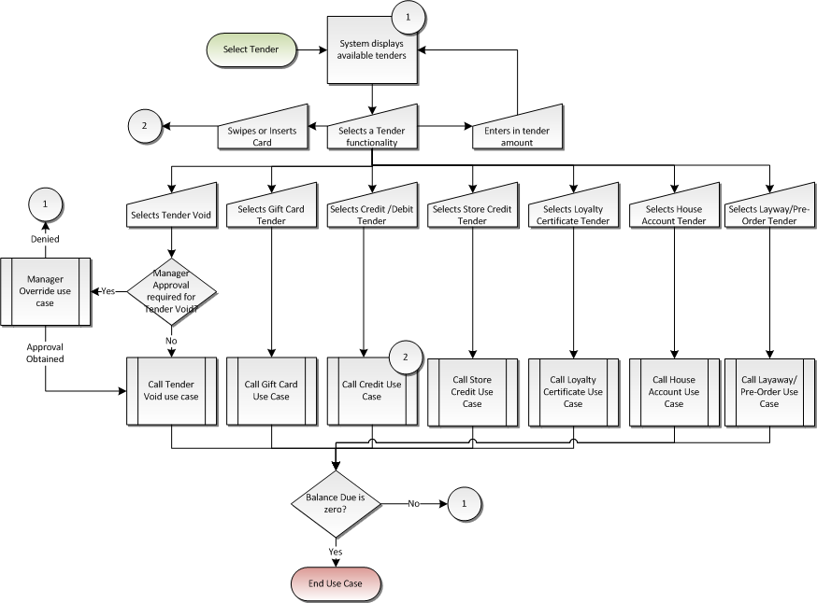

## Precondition

* Tender is selected.
* Total Processing is complete.

## Main Flow

1. The system displays the balance due as the default tender amount and prompts the operator to select a tender type or select an option.
2. If the operator selects to return to editing the transaction, the use case ends and the system returns to the Sale use case.
3. If the operator enters in an amount, the system changes the amount to tender to the entered amount.
4. If the operator swipes or inserts a card, the Credit use case is executed.
5. If the operator selects Credit/Debit, the Credit-Debit-EMV use case is executed.
6. If the operator selects Gift Card, the Gift Card use case is executed.
7. If the operator selects Store Credit Card, the Store Credit Card use case is executed.
8. If the operator selects Loyalty Certificate, the Loyalty Certificate use case is executed.
9. If the operator selects House Account, the House Account use case is executed.
10. If the operator selects Layaway/Pre-Order, the Layaway/Pre-Order Card use case is executed.
11. If the specified tender use cases return with a new tender amount, the Main Flow continues where the system applies the tendered amount to the transaction.
12. If the specified tender use cases return without a new tender amount, the Main Flow returns to the point where the system displays the tender options available.
13. The system applies the tendered amount to the transaction and updates the balance due and the amount tendered is added to the virtual receipt.
14. If the operator selects to void a tender, the Tender Void Manager Override alternate flow is executed.
15. If a balance due remains (amount greater than zero), the system returns to the Main Flow where the system displays the balance due as the default tender amount and prompts the operator to select a tender type or select an option.
16. If there is no balance due, then the Check for Signature Capture alternate flow executes for each tender in the transaction.
17. The use case ends and the system returns to the calling use case.

## Alternate Flows

### Tender Void Manager Override

1. The system evaluates if tender void requires manager override to continue.
2. If tender void does not require manager override, the system executes the Tender Void use case.
3. The system executes the Manager Override use case.
4. If the manager override is denied, the use case ends and the system returns to the calling use case.
5. If the Manager Override use case returns with an approved, the system executes the Tender Void use case. **Note**: The manager override is not queued, as the manager override occurred after total is selected.

### Check for Signature Capture

1. If the authorization decision response included a signature required, the system executes the Signature Capture (Tender) Use Case. Upon successful completion of signature, the system checks for signature capture of next tender in the transaction. If no other tenders to evaluate, the system returns to the Main Flow where the system ends the use case.
2. If the entry method was EMV and the card was captured manually, the system checks for signature capture of next tender in the transaction. If no other tenders to evaluate, the system returns to the Main Flow where the system ends the use case.
3. The system checks if signature is required based upon card type.
4. If signature is required, the system executes the Signature Capture (Tender) Use Case. Upon successful completion of signature, the system checks for signature capture of next tender in the transaction. If no other tenders to evaluate, the system returns to the Main Flow where the system ends the use case.
5. The system checks for signature capture of next tender in the transaction. If no other tenders to evaluate, the system returns to the Main Flow where the system ends the use case.

## Post Condition

* Tender(s) have been collected and authorized (where applicable)
* The balance due is zero.

## Special Requirements

1. Default Tender amount is the Balance Due value if not changed.
2. The system updates the virtual receipt in the order the tenders were applied in.
3. The global handle is not available on the Tender screen.
4. Loyalty Certificate is not available if a different tender has been used in the transaction.
5. The system accepts swiping of a card on the device or an external device while on the select tender screen.
6. The system accepts the inserting of a card into a payment machine while on the select tender screen.
7. During a Layaway Deposit transaction, the amount to collect for tendering is the amount entered for the layaway deposit not the transaction total.
8. If the transaction contains MCF Web Order Sale items, the system does not allow the operator to return to Item Entry.
9. If the transaction contains MCF Web Order Sale Items, the system writes a MCF Cancel Message if the user selects to void the transaction from the tender screen.

### Special Offline Requirements

TBD

### Data Input/Output

|  |  |  |
| --- | --- | --- |
| **Data Element** | **Description** | **Destination** |
| None |  |  |

# *Supplemental Specifications*

## Credit/Debit/EMV Feature

The system executes the Credit-Debit-EMV use case when the Credit tender option is selected or if a card is swiped or inserted into the payment device while on the tender screen.

## Electronic Journal

Electronic journal mockups for this feature are documented in the Electronic Journal Feature document.

## Gift Card Feature

The system executes the Gift Card use case when the Gift Card tender option is selected.

## House Account Feature

The system executes the House Account Tender use case when the House Account tender option is selected.

## Layaway/Pre-Order Feature

The system executes the Layaway/Pre-Order Tender use case when the Layaway/Pre-Order tender option is selected.

## Manager Override

The Manager Override feature is called if manager approval is required to void a tender.

## POSLog

POSLog mockups for this feature are documented in the POSLog document.

## Printed Receipts

Printed receipt mockups, where applicable, are documented in the Receipt Generation document.

## Tender Void Feature

The system executes the Tender Void use case when the Tender Void option is selected or the operator selects to return to Sale use case with partial tenders present in the transaction.

# *Screen Layouts*

## Tender Options

The Tender Options screen appears when the operator selects to collect tender information for the transaction.

The system accepts swiping or inserting of a card while on this screen and is an implied entry.

During a Layaway Deposit transaction, the Balance Due is the amount that the user entered as the layaway deposit amount. The Sub Total, Tax Total, Trans Total will remain the same, just the Balance Due is changed during a Layaway Deposit transaction type.

### Mockup

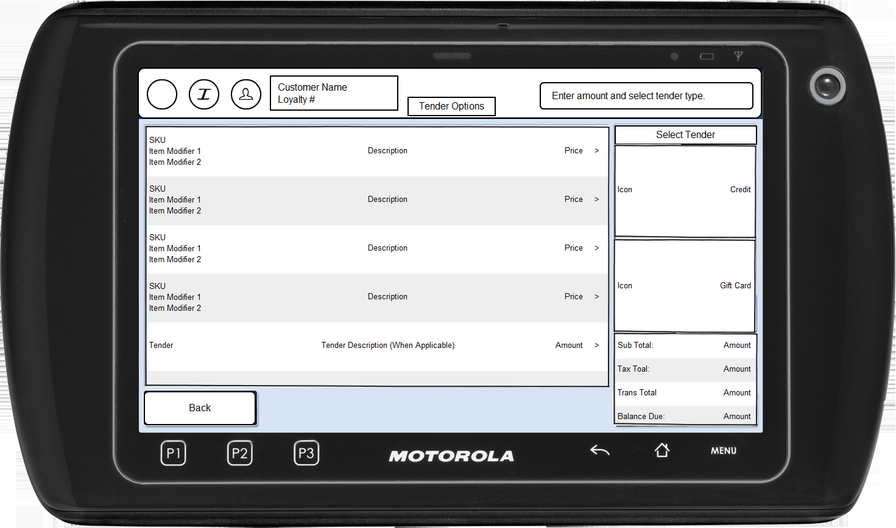

Figure 1: Tender Options

### Instruction Text

|  |
| --- |
| **Instructions** |
| None |

### Navigation/Menu Key

|  |  |  |  |
| --- | --- | --- | --- |
| **Label** | **State** | **Next Screen** | **Notes** |
| Credit/Debit | See Notes | Credit-Debit-EMV use case | The tender option is displayed based upon the Available Tenders by Device parameter and Transaction Type parameter. |
| Gift Card | See Notes | Gift Card use case | The tender option is displayed based upon the Available Tenders by Device parameter and Transaction Type parameter. |
| Store Credit | See Notes | Store Credit Card use case | The tender option is displayed based upon the Available Tenders by Device parameter and Transaction Type parameter. |
| Loyalty Certificate | See Notes | Loyalty Certificate Tender use case | The tender option is displayed based upon the Available Tenders by Device parameter and Transaction Type parameter.  Loyalty Certificate is not displayed if a different tender has been used in the transaction. |
| House Account | See Notes | House Account Tender use case | The tender option is displayed based upon the Available Tenders by Device parameter and Transaction Type parameter. |
| Layaway/Pre-Order | See Notes | Layaway/Pre-Order Tender use case | The tender option is displayed based upon the Available Tenders by Device parameter and Transaction Type parameter. |
| Back | See Notes | Active tenders not present: Sale use case | Not displayed when active tenders are present.  Not displayed if the transaction contains MCF Web Order Sale items. |
| <Swipe or Insert card> | Enabled | Credit use case | None |

### Data/Input Field

|  |  |  |  |  |  |  |
| --- | --- | --- | --- | --- | --- | --- |
| **Label** | **Editable** | **Req’d?** | **Data Type** | **Min**  **Length** | **Max**  **Length** | **Notes** |
| Enter amount and select tender type. | Yes | No | Currency | 1 | 8 | If an entry is not made, the system uses the balance due as the tender amount for the tender that is selected. |

### Reason Code

|  |  |  |
| --- | --- | --- |
| **Reason Code** | **Valid Values** | **Default Value** |
| None |  |  |

### Unable to Process Debit

|  |  |
| --- | --- |
| **Description** | The Unable to Process Debit message is displayed when the card type is debit but there is no payment device associated with the mobile device. Acknowledging the alert returns the operator to the calling use case. |
| **Message** | Unable to process debit tender |
| **Key prompt** | OK |
| **Notes** | Configurable message |

# *Business Sign Off*

|  |  |  |
| --- | --- | --- |
| **Name** | **Organization** | **Date** |
| <Name of signer> | <Organization of signer if applicable> | <date of sign off> |

# *Revision History*

|  |  |  |  |
| --- | --- | --- | --- |
| **Reviser** | **Revision** | **Date** | **Version** |
| Amy Lackas | Initial document created. Changed the use case to call for House Account and Layaway/Pre-Order Tender and for Layaway Deposit Transaction Type. | 10/28/2013 | 1.0 |
| Amy Lackas | Updates to add new feature: MCF | 11/01/2013 | 1.1 |
| Amy Byers | * Section 2.3: Added check for tender signatures after all tenders are applied to the transaction. * Section 2.4.2: Defined check for tender signatures. * Section 7: Added Requirements matrix | 10/6/2014 | 1.2 |

# Appendix : Source Documentation

* Requirement Specification - XPOS.xlsx

## Functional Requirements

| **ID** | **Sub Category** | **Description** | **Section(s)** |
| --- | --- | --- | --- |
| 4.2 | Tender | If multiple forms of tender are applied to the transaction that require the customer to provide their signature, all signature prompts will be queued until the entire transaction has been tendered. | * 2.3 Main Flow * 2.4.2 Check for Signature Capture |
| 4.2.1 | Tender | A customer will be required to sign for each instance of a signature required MOP, however they will not sign after each tender, but once all tenders have been applied to the transaction. | * 2.3 Main Flow * 2.4.2 Check for Signature Capture |
| 5.1 | Layaway Deposit | Layaway Deposits will be accepted as a valid form of payment. | * 2.1 Feature Flow |

# *Appendix : Glossary*

|  |  |
| --- | --- |
| **Term** | **Definition** |
| Authorized tender | A tender type that requires authorization from a 3rd party vendor or service. Examples include credit card and gift cards. |
| Tender | The collection and application by the retailer of forms of payment to pay for goods and/or services. |